Digital Signature Standard (Simulation using RSA & Hashing)
Aim
To simulate a Digital Signature generation and verification process using a cryptographic hash combined with asymmetric encryption principles (RSA/Signature concept).
Algorithm
- Message Preparation: Take the original message input text.
- Digest Generation: Create a message digest (hash) of the message text.
- Signing (Private Operation): Encrypt the hash digest using a sender's "private key" formula ($Signature={\left(Hash\right)}^{d} \left(mod n\right)$).
- Verification (Public Operation): Decrypt the signature using the matching "public key" ($DecryptedHash={\left(Signature\right)}^{e} \left(mod n\right)$).
- Validation: Compare the decrypted signature hash against the freshly computed hash of the received message. If they match, the signature is valid.

Program:
#include <stdio.h>
#include <string.h>

// Simple modular exponentiation function: (base^exp) % mod
long long power(long long base, long long exp, long long mod) {
long long res = 1;
base = base % mod;
while (exp > 0) {
if (exp % 2 == 1) res = (res * base) % mod;
base = (base * base) % mod;
exp /= 2;
}
return res;
}

// Simple pseudo hash function mapping string to a small integer
long long simple_hash(const char* msg) {
long long val = 0;
for(int i = 0; msg[i] != '\0'; i++) {
val = (val * 31 + msg[i]) % 1000;
}
return val;
}

int main() {
// RSA keys setup (p = 61, q = 53 => n = 3233, phi = 3120, e = 17, d = 2753)
long long n = 3233;
long long e = 17; // Public key component
long long d = 2753; // Private key component

char message[] = "AuthorizeTransaction";

printf("--- DIGITAL SIGNATURE EXPERIMENT ---\n");
printf("Original Message: %s\n", message);

// Step 1: Hash the message
long long msg_hash = simple_hash(message);
printf("1. Message Hash Digest: %lld\n", msg_hash);

// Step 2: Sign the hash using Private Key (Signature = Hash^d % n)
long long signature = power(msg_hash, d, n);
printf("2. Generated Digital Signature: %lld\n", signature);

// --- TRANSMISSION OVER NETWORK ---

// Step 3: Receiver verifies signature using Public Key (Decrypted Hash = Signature^e % n)
long long decrypted_hash = power(signature, e, n);
long long recalculated_hash = simple_hash(message);

printf("3. Decrypted Hash from Signature: %lld\n", decrypted_hash);
printf("4. Recalculated Message Hash: %lld\n", recalculated_hash);

// Step 4: Validation check
if (decrypted_hash == recalculated_hash) {
printf("\nRESULT: Verification SUCCESSFUL! The Digital Signature is authentic.\n");
} else {
printf("\nRESULT: Verification FAILED! Message or signature was tampered with.\n");
}

return 0;
}
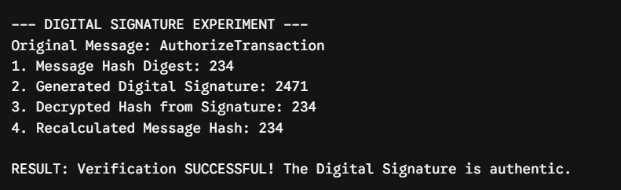
Result:
thus the program has successfully executed and compiled with perfect output.

